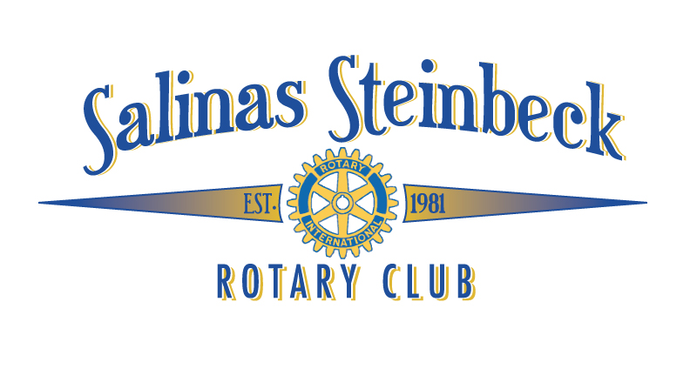
February 7, 2017

Dear “Sponsor”,

The Salinas Steinbeck Rotary Club is excited to host its second annual street fair and major fundraiser called “Steinbeck’s Home Brew Fest” to take place on May 6, 2017. Our inaugural event last year was a great success and raised funds that benefited our local area. We are asking for your support for the event.

The street fair will take place between 11:00 a.m. and 4:00 p.m. on the 100 block of Main Street. To raise funds for our Rotary projects, we also will be selling 750 tickets for beer tasting at three beer gardens where 30 local amateur brewers will share their expertise and tasty creations.

Salinas Steinbeck Rotary Club has a long history of community and international projects. Through our commitment to Everett Alvarez High School (“EAHS”), we support an Interact group that has over 100 members who will be our future leaders. These young adults organize and implement charitable projects locally and internationally.

Other projects include: Rotary Youth Exchange; EAHS TOP 100 Dinner, EAHS Leadership, Camp Royal High School Leadership, Literacy Grants to local schools, the Annual All-Star Basketball Game, Franciscan Workers Sanitation Project, student scholarships. We also use the power of Rotary to join with other Rotary Clubs for international projects.

Enclosed are our levels of sponsorship and recognition opportunities. We hope that you will partner with us in supporting this event. Salinas Steinbeck Rotary Club Foundation is a 501c3 organization and our tax ID# is 20-1753312.

Thank you for your consideration and please contact us for any questions.

Sincerely,

Anne Frassetto Olsen, Event Co-Chair, 831-320-4938
Cary Swenson, Event Co-Chair
Salinas Steinbeck Rotary Club
P. O. Box 1641
Salinas, CA 93902

