Kruise into
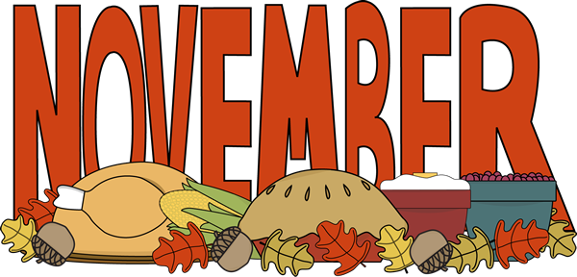
with Kathy’s Kruisers
Nov 1st: Interact Students Presentation Speaker: Hortencia Jimenez, PhD: Youth Civic Engagement
Dr. Jimenez is an author and faculty member in the Sociology department at Hartnell College.
NOV. 3rd: CLUB SOCIAL: 1st Friday Art Walk and Dinner
Meet at the Steinbeck Center at 5:30pm and join fellow Rotarians as we enjoy the many venues.
Then meet for dinner and live music location TBA
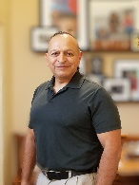
Nov. 8 ^{th:} Speaker: Tony Villeruta: Volunteerism
Organizer of the Salinas Veterans Day Parade
Nov. 12th : An opportunity for community Service as we host Hartnell College’s viewing of Young Frankenstein
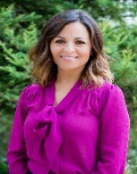
Nov 15^{th:} EAHS ASB Presentation - Speaker: Guille Barbosa: An introduction to the Big Sur Land Trust and our work in the Salinas Valley specifically in the Carr Lake area.
Guille began her career with The Big Sur Land Trust in 2002 as Executive Assistant to the CEO. Currently she provides support to the Development and Communications/Community Engagement Departments.
Wish a Happy Birthday and Anniversary to your fellow Rotarians!
Nov 22nd: DARK - HAPPY THANKSGIVING!!!
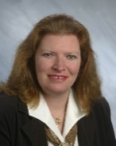
Nov 29^{th:} Speaker: Anne Appel: The Rotary Foundation for Dummies
Anne has held many positions in our district since founding Monterey Pacific Rotary Club in 2005. She has held numerous offices on the District level and received Rotarian of the year for District 5230 in 2010. Currently she is the Rotary Director of Administration for District 5230.

